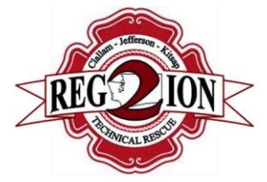 | Kitsap County Special Operations Team  Polices and Guidelines
Title: 4.1, Annual Skills Qualification |  | Section/Topic: Training
Effective Date: October 5th, 2020 |  | Classification: Policy

Purpose:
To establish an annual skills qualification/certification procedure for all Kitsap County Special Operations personnel.

Scope and Applicability:
All KSORT Personnel

Definitions:

References:
NFPA 1006
NFPA 1670

Policy:
It is the policy of the Kitsap County Special Operations Team to conduct and utilize identified processes to ensure that members continue to meet the expectations of capability established in the “Minimum Requirements” section of their respective position description.

Procedure:

- Skills qualification/certification evaluations shall be conducted on an annual basis.

- Each fire agency participating in KSORT is responsible for maintaining records of training and qualifications for their respective members assigned to KSORT

  - Such records shall be made available for to KSORT as necessary.

- The Region 2 Technical Rescue Team Coordinator, assigned Rescue Group Supervisors, and/or their designees will evaluate each other separately from the rest of the team. After completion of their evaluations, they will evaluate the remaining members of the team.

- The evaluators will conduct the evaluation using a skills check-off list or “task book”. This list or book will contain the required skills encompassing all pertinent areas of rigging and technical rescue. The most current edition of KSORT Operations Manuals will be the foundation for the required skills.

- Successful performance of all tasks, as observed and recorded by a certified Rescue Technician in that discipline, will result in the candidate’s eligibility for qualification.

- Skills are to be tested after the candidate has completed the training program and by using the available equipment provided by the agency.

- The candidate needs only perform the skill once, without coaching, to be complete

- Members failing their first attempt shall be provided a second attempt using a different evaluator.

- Personnel failing their second attempt will be removed from deployment eligibility and provided 30 days to retest.

- Personnel failing to schedule a retest or failing their third attempt will be removed from deployment eligibility until such time as they might reschedule remedial training and retesting.

  - Notification will be sent to their respective agency Operations Chief outlining the skills deficiency.

  - Repeated failures to perform or reschedule may result in the member being released from the team.

- Continuing education necessary to maintain all requirements of the level of capability shall be provided by the fire department.

